Information technology

v/s

Operational Technology

Although Information technology and Operational Technology are treated as separate fields , on the contrary, these two worlds are highly entwined and co-existent , more than we can imagine.

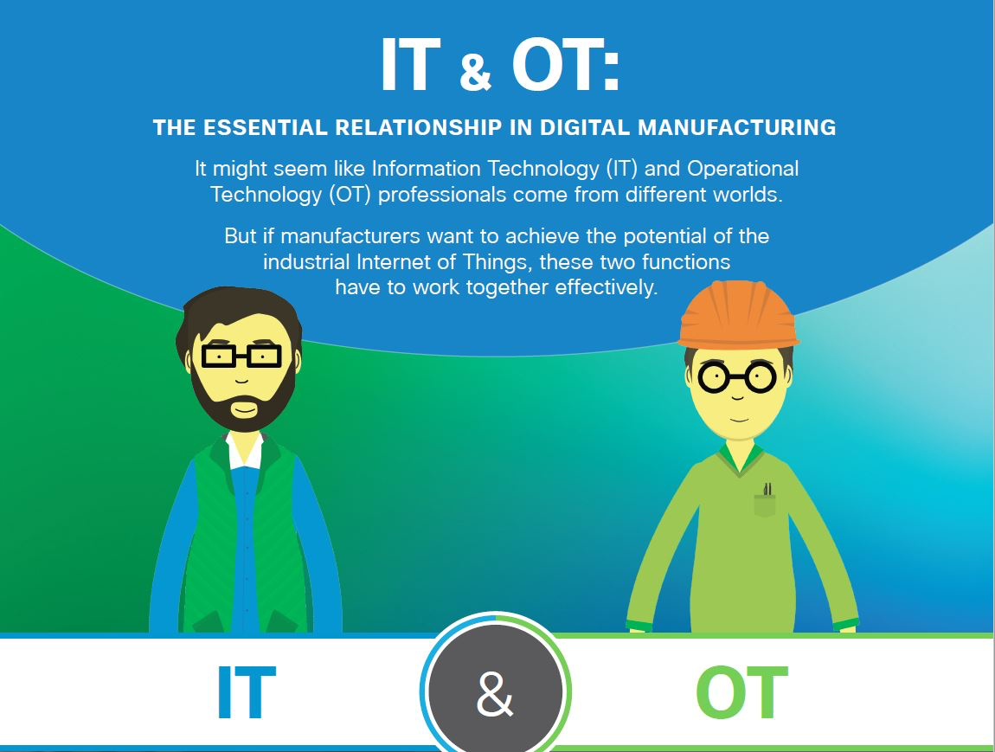

HIGHLIGHTS :

* What is Information and Operational Technology
* Industrial Control Systems and their benefits
* What are the major technical aspects in IT and OT?
* Throwing light on the cloud computing Infrastructure

Before diving into the technical terminologies related to IT and OT, let us have a quick look at the basic level to grasp the gist in a glimpse.

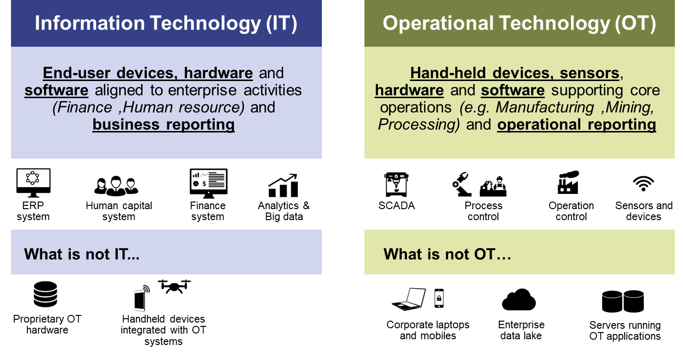

|  |  |  |
| --- | --- | --- |
| Category | IT systems | OT systems |
| Includes | Data and the flow of digital transformation | Operation of physical processes and machinery used to carry them out |
| Primary focus | * Data confidentiality and integrity * automation of business processes * information management and manipulation | * safety and protection of processes and equipment * response to human and emergency interaction * controlling physical processes |
| Performance requirement | * Non -real time * High throughputs demands * Downtimes acceptable | * Real time * Time critical responses * Downtime unacceptable |
| Data | * Complex data type * Multilayered analytics * Low data rate | * Simple data type * Just -in -time analytics * High data rate |
| Interface and networks | * ERP systems * CRM software * SQL * Web browser * Keyboard * Cloud Computing | * Industrial control systems * SCADA system * Industrial Automation * Process control networks |

**What is Operational Technology?**

**Operational Technology (OT) encompasses all the real time machinery and technology there is , that perform industrial operations. It ranges from hardware too software used in changing , monitoring or controlling physical devices and processes within an organization.**

Few of the examples of Operational Technology include Plant floor control systems , automated teller machines(ATMs), Civil Infrastructure (e.g. tollway automation and water management), Supervisory Control and Data Acquisition(SCADA) , and many more. Several OTs rely on devices such as Programmable Logic Controllers) that receive input from input devices or sensors , process that data and execute some task accordingly based on pre-programmed parameters. However , OT devices are highly specialized and rarely run on standardized operating systems , instead they make use of custom software to function. This is because OT devices can be accessed only by a reserved group pf people who are highly trained members of an organization and thus they may or may not be updated for several years.

**Terms related to OT:**

1) INDUSTRIAL CONTROL SYSTEMS (ICS)

Industrial control systems are a type of OT and simply a collection of individual control systems and other hardware which work together to automate or operate industrial processes. ICS are basically used to reduce human effort by making everyday operations and processes more efficient and productive . They come in various forms such as process control systems , data acquisition systems and distributed control systems.

1)Process control Systems – These are the systems that are entitled to making sure that processes throughout the product line operate smoothly and as they should. They test all the processes in several ways and then return the data for monitoring and troubleshooting. The idea behind using them is to ensure that production is consistent , efficient and resourceful.

Benefits in a glimpse:

* Reduces energy wastage
* Consistency in product quality
* Reduced manufacturing costs
* Enhanced security
* Environmental friendly(warns of rise in emissions)

2)SCADA Systems

Supervisory Control and Data Acquisition Systems or simply SCADA systems , as the name suggests are responsible for centralized monitoring and control of a plant’s field sites. This system designed for supervision , collects data on the process and sends the command control to the process. They are at the core of many modern industries, acting as their backbone, helping them maintain efficiency , process data for smarter decisions and communicate system issues to help reduce downtime. Basic architecture in a SCAD system includes programmable logic controllers(PLCs) or remote terminal units (RTUs) which are nothing but microcomputers that communicate with an array of objects like HMIs (human -machine interface),sensors and route the information into SCADA software. If you observe carefully , there is a system SCADA system working in the background at most places . Modern SCADA systems also allow the access of real-time data of plant floor from any place in the world. The introduction of modern IT standards and practices into SCADA software have led to drastic improvements in efficiency, security , and reliability of the system. Major benefits:

* Monitoring, gathering and processing real-time data
* Direct interaction with devices like sensors, valves and more through human -machine interface(HMI) software.
* Supervision of industrial processes locally or remotely.
* Recording events into a log file

3)INDUSTRIAL AUTOMATION (IA)

We are all ware about how rapidly technology is advancing and all the industries and factories are transitioning from mechanization to automation. Now this is where Industrial automation comes into play.

Industrial automation is the use of control devices to handle processes and machinery in industries by reducing human intervention as much as possible and replacing it with automated technology. In today’s world , Industrial automation is extensively practiced in practically every type of manufacturing company .

Benefits of Industrial automation:

* **Improved quality**: As it includes drastically reduced human intervention , it is less prone to errors . The precision that automation provides results in higher consistency and increased productivity which ultimately results in improved quality.
* **Higher efficiency**: Humans cannot operate 24/7 , however that is not the case with robots . They not only work fast and more efficiently but also provide for flexibility to adjust the work cell.
* **Improved speed** : availability of a more efficient production line thus reducing product lead times .
* **Enhanced safety**: Operators do not need to carry out dangerous tasks such as working with hazardous chemicals, working in high temperatures and perform tasks with repetitive motion.

4)PROCESS CONTROL NETWORKS

A process control network is a communication network layer that comes under IA in process industries and is used to transmit data and instructions between control and measurement units and SCADA systems.

Benefits:

* Improves safety
* Reduces Overhead costs and unplanned downtime by empowering operators with actionable data
* Process becomes more efficient and produces higher quality products with greater consistency.
* Provides for increased process visibility to make sure that your data doesn’t fall into the wrong hands

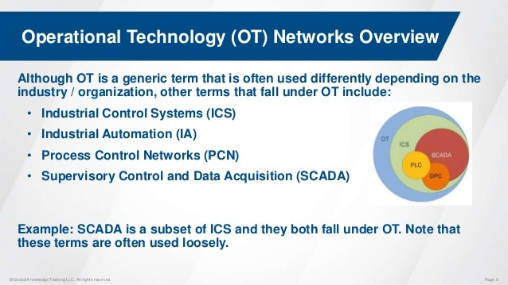

**What is Information Technology?**

Information technology in simple words is the technology required for information processing involving the use , development and maintenance of computer systems , software and networks. Consider it as a big umbrella covering anything ranging from software to hardware and anything related to computer technology. IT forms the technological backbone of many organizations . These programs are updated frequently unlike OT , and also the access to IT programs and devices is less restricted than OT .

The major difference between IT and OT is that OT devices cover the physical aspects, that is to say , they control the physical world whereas IT system is in charge of managing data.

Enterprise Resource Planning(ERP)

An ERP is a software or an application that makes use of a central database to manage day to day business activities such as accounting , risk management and compliance , supply chain operations etc.

The ERP receives Information from various departments within a company and contains integrated modules that perform various operations on the data . The main purpose of an ERP system is to increase the organizational efficiency by looking over on how the resources of a company are utilized and can be improved.

Benefits of ERP software:

* **Improves Process Efficiency** : by eliminating repetitive processes and also streamlines business processes , thereby making it easier and efficient for companies to collect data.
* **Accurate forecasting:** aids in stronger forecasting which further helps in decreasing business costs, saves money and becomes an overall protective unit.
* **Data reliability** : ERP system provides reliable data that can be accessed from various locations and through multiple devices . With the ability to update in real time, ERP improves data accuracy and consistency. With this, users can ensure that all data and analytics are safe to use.
* **Integrated information:** ERP acts as a central reserve for all the important data . All information at a central hub means that one can easily integrate platforms with ERP , keeping our data accurate and consistent.

Structured Query Language(SQL)

Structured query language also known as SQL is a standard programming language that is used to create , maintain, and retrieve data from relational databases .

Using SQL , we can update ,and reorganize data , as well as store data on every organization or client you ever worked with, from smallest to the biggest details.

Benefits of using SQL:

* Quick and efficient retrieval of data
* No coding required
* Has well defined standards
* Portable and platform independent
* Provides for multiple data views

CUSTOMER RELATIONSHIP MANAGEMENT (CRM)

Customer relationship management as the name suggests, is a software used for managing the relationships and interactions of a company with their customers and potential customers. The main aim of this technology is to strengthen and improve business relations , stay connected to customers , streamline the work and provide for enhanced profitability.

ROLE OF CRM IN IT INDUSTRY: CRM enables IT companies to improve operational efficiency by automating salesforce and enterprise operations . It enhances customer support and increases market share and lifetime value of the customer.

Benefits:

* Enhanced customer experience
* Btter resource management and budget planning
* Faster and improved communication among customers, partners, employees , etc.
* Growth stabilization

CLOUD COMPUTING INFRASTRUCTURE

We all have heard that cloud computing has lately been causing a major shift in the IT industry and has been a revolutionary technology trend for businesses across the globe. So what is this technology?

Cloud computing is like an umbrella term for cloud technology. Cloud architecture refers to all the hardware , software and systems that make up the infrastructure of a computing cloud. Cloud computing technology provides users access to files, software , storage and servers through their interconnected devices . It enables us to access data over the internet rather than on a hard drive.

It consists of several components that can be grouped into 5 layers, namely – hardware , virtualization, platform , application and client layer.

Benefits:

* **Cost reduction :** Cloud computing provides for low cost maintenance, and utility management for the servers. They are a fraction of the cost of the locally installed software.
* **Security :** Data held in the cloud infrastructure is way less prone to employee theft. Cloud computing puts a safe distance between the data and employees and thus no disgruntled employee can misuse it.
* **Reliability:** In cloud computing data is stored in servers in multiple locations which means that a single hardware failure will not cause much damage.

CONCLUSION

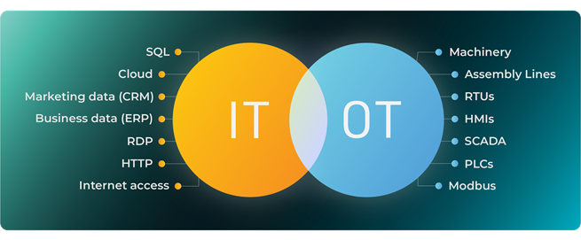

While IT and OT appear as two separate aspects of modern organizations and seem to be world apart , the gap between IT and OT is being bridged through a phenomenon called IT -OT convergence . In the upcoming blog we will be covering both these topics and dive into greater detail . To conclude what we learnt in this article , let us have a look at the table given below.

